Kumar Ravikumar
Rgvkumar406@gmail.com
9840240815

Excel Assignment 2 – Data Exploration
1. Handling Missing Values:
There is no missing value in Price column
Ctrl + G -> Clicked bottom Special option ->Select Blanks -> Ok
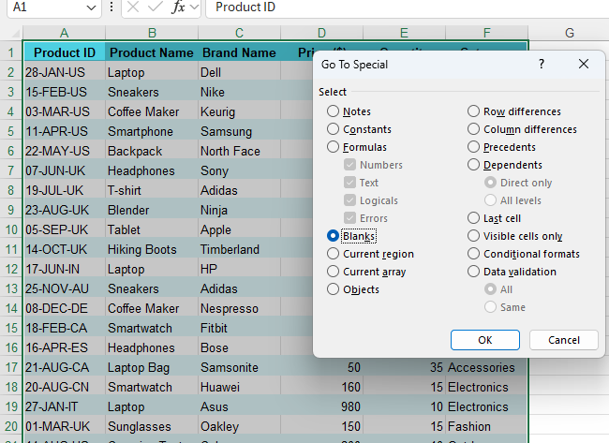
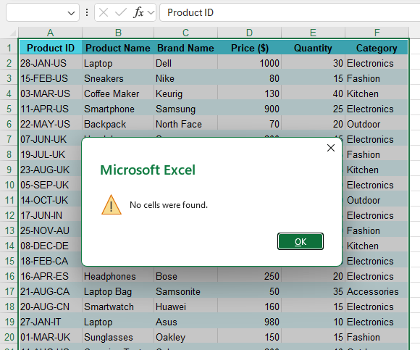

- Correcting Inconsistent Data:
There is no inconsistent details in Product Name
Used "G" column for "PROPER" Formula

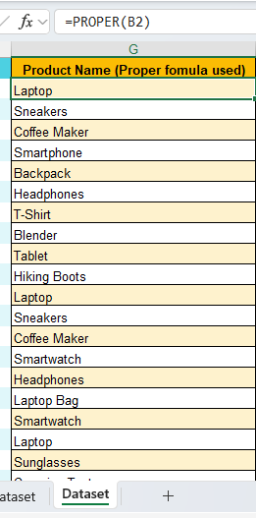
There is no typos present in Category column and also there is no misspellings in the "Product Name" and "Category"
If it typo error presented I will used Find and Replaced option (Ctrl +F -> Incorrect value search and Replaced with Correct values)

- Removing Duplicates:
2 Duplicates find that's has been removed
Selected entire dataset -> Data -> Remove Duplicates -> Entire Row ->Ok
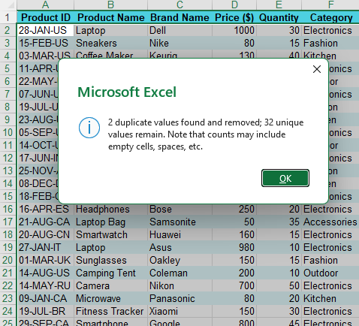

- Splitting and Merging Data:
Used Product ID Column and Created two separated Columns "H" (Manufacturing Date) and "I" (Country Code) and formula applied there is no unnecessary column.
For Manufacturing Date used formula =LEFT(A2,6) and for Country Code used Formula =RIGHT(A2,2) and drag the formula entire column
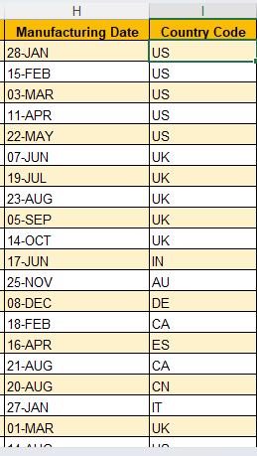
Merged the Brand name and Product name in "J" Column
Used "J" column for "=C2 & " " & B2" Formula
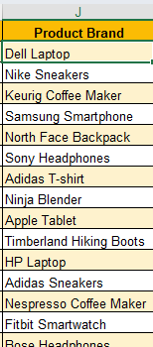
5. Number Formatting
"K" Column created for Price and applied currency format
Used "K" column for goto Home -> selected currency type
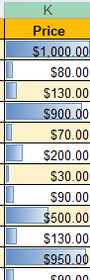

- Conditional Formatting:
Applied Data bar and color scales in "K" Column
Used - Home -> Conditional Formatting -> Data Bars -> Choose any style


Created custom rule for Category column "L"
Click "L" column go to Home -> Conditional Formatting - Highlight Cells Rules - Text "Electronic" and then select colour hit ok
